# Deliverable 1-Schema Design Requirements

The following document contains the requirements related to the first deliverable of the Database Systems Lab web project. In this document, we will primarily discuss your project database schema. We will also discuss version control via Git, Github and deployment on cloud via Microsoft Azure, as add-ons.

Let’s talk about the **add-ons** first, because they are equally important.

## Version Control

Version control, also known as source control, is the practice of tracking and managing changes to software code. Version control systems are software tools that help software teams manage changes to source code over time. As development environments have accelerated, version control systems help software teams work faster and smarter.

Version control software keeps track of every modification to the code in a special kind of database. If a mistake is made, developers can turn back the clock and compare earlier versions of the code to help fix the mistake while minimizing disruption to all team members.

### Git

[Git](https://git-scm.com/) is a free and open source distributed version control system designed to handle everything from small to very large projects with speed and efficiency.

**Download Git:** <https://git-scm.com/downloads>

Git usually comes with a built-in GUI tool and a Bash tool. If not, you can always download a [third party GUI tool](https://git-scm.com/downloads/guis/).

### Github

To use Git with ease, we need a web client. This is where Github comes in.

Create a [Github account](https://github.com/join?ref_cta=Sign+up&ref_loc=header+logged+out&ref_page=%2F&source=header-home). Since you are a student, it is always better to sign-up with your NU student email address.

Create a [new repository](https://docs.github.com/en/github/getting-started-with-github/create-a-repo) (private) and start working. I have listed some important Git commands in this [article](https://towardsdatascience.com/git-commands-cheat-sheet-software-developer-54f6aedc1c46?sk=f72f51b1e1893552e99233ea8f6305d1) (Open in Chrome or Mozilla). Do check it out.

## Deployment

We are going to take our little project live (or known as production). This is one of the most important phases of a project life cycle since it gives us a sense of achievement. Plus, you will have something to show as proof that you are a web developer and you can deliver web applications. Just make sure it looks good.

## Azure

The Azure cloud platform is more than 200 products and cloud services designed to help you bring new solutions to life—to solve today’s challenges and create the future. Build, run, and manage applications across multiple clouds, on-premises, and at the edge, with the tools and frameworks of your choice.

Of the [Fortune 500](https://fortune.com/fortune500/) companies, 95 percent rely on Azure for trusted cloud services. Companies of all sizes and maturities use Azure in their digital transformation. Let’s get into it.

Create a free [Microsoft Azure account](https://azure.microsoft.com/en-us/free/). With free account, you will get $200 credits for 12 months. You can utilize these credits to run Azure services.

**BEWARE, if you have added your Debit/Credit card details, you will be charged once you run out of free credits or your free trial ends.** But for a project of our scale, this is highly unlikely. Use your NU student email address to activate Azure Student subscription.

Once your account is created. Open the Azure portal and get to work.

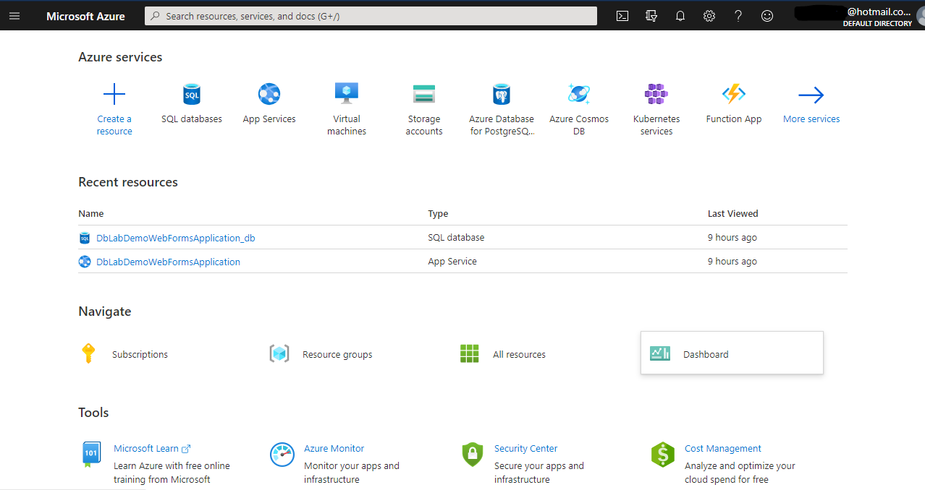

## Schema Design

Create a database and include all the necessary tables for your Web Project.

## Database Diagram

You are required to submit a database diagram. You can generate one using the **New Database Diagram** option in the **Object Explorer** of MSSQL Server Management Studio under your database’s **Database Diagrams** folder. Right click on this folder to open the options. Refer to screenshot below.

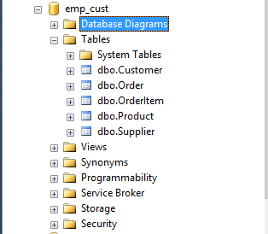

Add the required tables to your diagram.

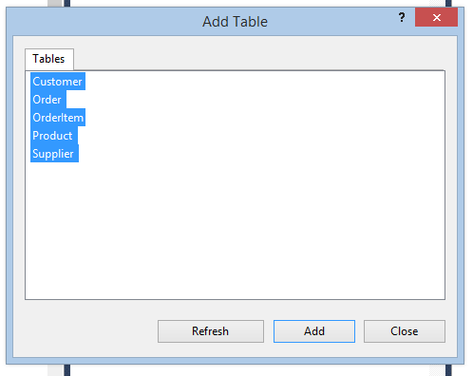

Diagram is generated. Rearrange the diagram to fit it on screen and make it look NOT ugly.

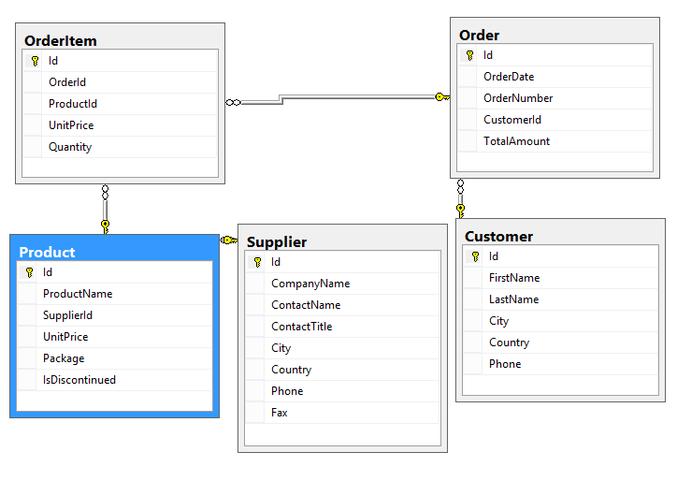

When you are done, right click on the diagram space other than the tables and select **Copy Diagram to Clipboard.** Paste this copied diagram in a word document and submit this document.

### Submission Instructions

* You are required to submit two files for this deliverable.
* One file would contain complete database scripts which includes tables, constraints, and data.
* File name format should be as such: **project_name_scripts.sql** e.g. uber_scripts.sql
* Other file would contain the database diagram only.
* File name format should be as such: **project_name_schema_diagram.docx** e.g. uber_schema_diagram.docx
* Submit these files under the assignment **Deliverable 1 - Schema Design** on Google Classroom by **Thursday April 15th, 2021.**
* **DONOT rar or zip** these files.
* Only one group member should submit the schema. No duplicate submissions.

## What’s Next?

Read the Deliverable 2-Graphical User Interface Requirements document for details